Chapter 2, Solution 31

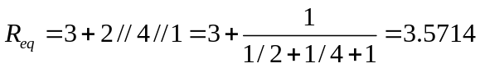

i₁ = 200/3.5714 = 56 A

v₁ = 0.5714xi₁ = 32 V and i₂ = 32/4 = 8 A

i₄ = 32/1 = 32 A; i₅ = 32/2 = 16 A; and i₃ = 32+16 = 48 A

